2024
Wilson, Damian T
Cal State University Los Angeles
11/25/2024
The Implications of a Dying World

Data Set URL:
https://www.kaggle.com/datasets/sevgisarac/temperature-change?resource=download
INTRODUCTION-
Global warming, primarily driven by human activities, is one of the most pressing challenges of the 21st century. It refers to the long-term increase in Earth's average surface temperature due to the buildup of greenhouse gases (GHGs) like carbon dioxide (CO₂), methane (CH₄), and nitrous oxide (N₂O) in the atmosphere. These gases trap heat, leading to rising temperatures, melting ice caps, and extreme weather patterns. As the planet warms, the consequences become more severe, including rising sea levels, loss of biodiversity, and disruptions to agriculture and water resources (Deman,2024). Addressing global warming requires comprehensive strategies that focus on both mitigation (reducing emissions) and adaptation (adjusting to its effects).
The most effective strategy for combating global warming is reducing the emissions of GHGs, which largely come from the burning of fossil fuels for energy. A major focus is on transitioning to renewable energy sources such as wind, solar, and hydropower, which produce little to no GHG emissions. According to the International Renewable Energy Agency (IRENA), renewable energy is central to decarbonizing the global economy. Additionally, enhancing energy efficiency across all sectors, transportation, buildings, and industry—can significantly lower energy consumption and emissions.
Carbon capture technologies aim to capture CO₂ emissions from industrial processes before they are released into the atmosphere and store them underground or in other long-term storage sites. This technology is seen as essential for decarbonizing sectors like cement and steel production, which are challenging to fully electrify. CCS is considered a vital component of climate strategies to achieve net-zero emissions.
Forests play a critical role in absorbing carbon from the atmosphere. Therefore, reforestation (restoring deforested areas) and afforestation (planting new forests) are important strategies for increasing carbon sequestration. Programs like the United Nations’ REDD+ aim to reduce emissions from deforestation and promote sustainable land management practices. These efforts not only mitigate climate change but also enhance biodiversity and protect ecosystems.
Agriculture contributes significantly to global warming through methane emissions from livestock and rice paddies, and nitrous oxide from fertilizers. Adopting sustainable farming practices such as precision agriculture, crop rotation, and agroforestry can reduce emissions while maintaining food security. Moreover, increasing carbon sequestration through techniques like no-till farming helps capture carbon in the ground.
Given that some effects of global warming are already unavoidable, it is crucial to implement adaptation strategies. These include building resilient infrastructure, such as flood defenses and drought-resistant water systems, and strengthening disaster risk management to protect vulnerable populations from extreme weather events. Enhancing resilience is key to reducing the economic and social impacts of climate change.
International cooperation is essential in addressing global warming. Agreements like the Paris Agreement aim to unite countries in efforts to limit global temperature rise to below 2°C, ideally 1.5°C, above pre-industrial levels. Countries are expected to submit national plans for reducing emissions, increasing renewable energy use, and enhancing climate resilience. Additionally, carbon pricing mechanisms such as carbon taxes and cap-and-trade systems are being explored to provide economic incentives for reducing emissions.
The understanding the data and implementing strategies to combat global warming are diverse and require a multifaceted approach involving mitigation, adaptation, and international cooperation. Transitioning to renewable energy, implementing carbon capture technologies, promoting sustainable land use, and adopting climate-resilient practices are vital components of a global response. Governments, businesses, and individuals must work together to meet the challenge of global warming and ensure a sustainable future for the planet. The maps shows over the years how temperature is rising and its detrimental for every life form on earth (NASA, 2024).

Screenshot(s) of Data:

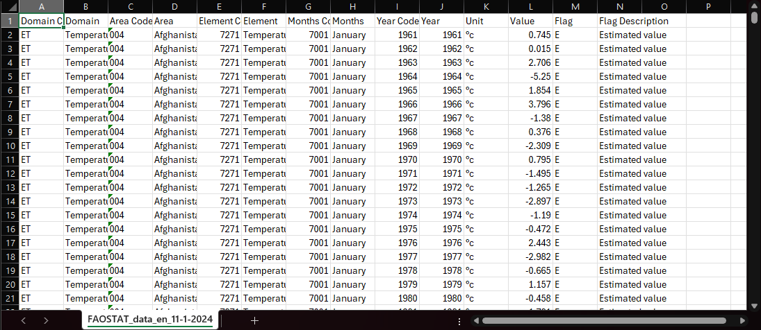

Data Description: (Table)
Field Name: Country | Description: The location of where the weather changing.
Field Name: Months | Description: The determination of weather changes within that specific month.
Field Name: Year | Description: The determination of weather changes within that specific year.
Field Name: Unit | Description: The degree of Celsius of weather.
Field Name: Domain | Description: The physical location of weather changes is occurring. For example, “East, West, North, South regions”.
Field Name: Element | Description: Showing that there is a weather change in that region.
Field Name: Year Code | Description: The specific year showing that weather changes occurred.
Field Name: Value | Description: The degree of Celsius of weather pertaining to specific year.

Questions of Analysis:
- How would understanding the data help us better understand and make changes?
- What are the primary drivers of Global warming?
- What are the current and future impacts of global warming on ecosystems and biodiversity?
- How do different regions of the world experience the effects of global warming?
- What are the socioeconomic consequences of global warming?

Works Cited
Dewan, Angela. “The World Just Marked a Year above a Critical Climate Limit Scientists Have Warned About.” CNN, Cable News Network, 8 Feb. 2024, www.cnn.com/2024/02/08/climate/global-warming-limit-climate-intl/index.html.
“Global Surface Temperature.” NASA, NASA, 7 Feb. 2024, climate.nasa.gov/vital-signs/global-temperature/?intent=121.

